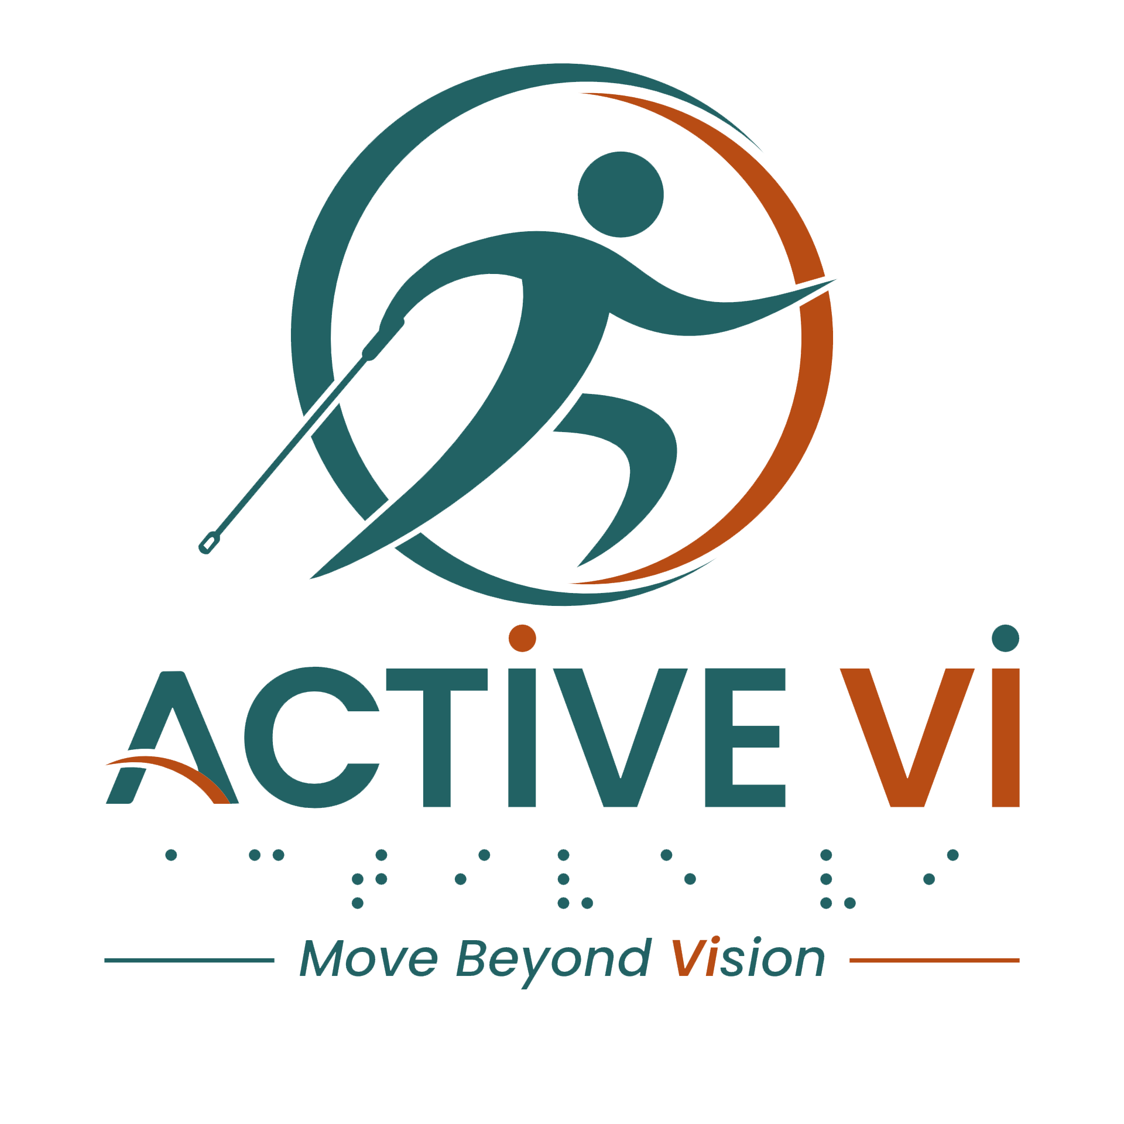

Transcript: EXERCISE AT HOME - Gentle Chair Yoga
Duration: 12.56 minutes
Watch the Video: Exercise at Home: Gentle Chair Yoga on YouTube.

[Background Music: A minimalist, acoustic ambient track with warm lo-fi piano and gentle nylon-string guitar plays softly throughout the video.]

[Visual: The video opens with a woman sitting in a chair in a bright, clean room, wearing an ACTIVE VI T-shirt, with two arms raised to the sky. The ACTIVE VI - Move Beyond Vision logo appears on screen along with the website www.activevi.sg. The title text reads: EXERCISE AT HOME Gentle Chair Yoga.]

Instructor (Voiceover): Welcome everyone. Today, we are going to do some simple exercises at home. All you need is a chair.
[Visual: The participant sits comfortably with her hands resting on her thighs, facing the camera.]
Instructor (Voiceover): Find yourself seated comfortably on the chair, keep your back straight, away from the backrest of the chair. We start with simple exercises to loosen out the body. Beginning with the head. Lift the chin up to the sky.
[Visual: The participant gently tilts her head back, lifting her chin.]
Instructor (Voiceover): Feel the stretch to your throat. And bring the chin down to your chest. Feel the stretch to the back of your neck. Lift the chin up again all the way to the sky. Feeling the stretch. And bring the chin down to your chest again. One more time. Lift the chin up to the sky. Feeling the stretch. And gently bring the chin down to your chest. Keep your head straight, neutral.
[Visual: The participant follows the instructions as described, brings her head back to a neutral, forward-facing position.]
Instructor (Voiceover): Keep your shoulders relaxed. Now we are going to do some tricep stretch. Raise your left hand up from the front towards the ceiling. Bend your left arm, left hand to the back of your head. Right hand holding onto the left elbow, try to push the elbow up. Feel the stretch to your left tricep. Hold for 5, 4, 3, 2, 1, and return back to a comfortable seated position.
[Visual: The participant stretches her left tricep as described, then returns her hands to her lap. She repeats the movement on the right side.]
Instructor (Voiceover): We will stretch on the right arm. Raise your right hand up from the front. Right hand to the sky, bend your right arm. Right hand to the back of the head, left hand holding onto the right elbow, try to push the elbow up. Feel the stretch to your left tricep. Hold for 5, 4, 3, 2, 1, and release. Both hands back on your thighs.
[Visual: The participant follows the instructions. Then she sits tall and prepares for the next movement.]
Instructor (Voiceover): Now we are going to do some spinal twist that release the tension to your back. Lift your both arms up from the front, fingers to the sky, turn the body to your left. Right hand holding onto the arm of the chair or on your left thigh, left hand holding onto the back of the chair. Sit with your back straight, turning your head over your left shoulder. Hold for another 3, 2, 1.
[Visual: The participant holds the seated spinal twist, looking over her left shoulder.]
Instructor (Voiceover): Lift both your arms up to the sky, untwist, and put both hands back to your thighs. We will do the same twist on the other side. Raise your both hands up from the front, hands to the ceiling. Turn to your right side. Keep your shoulders relaxed. Right hand holding onto the back of the chair, left hand holding onto the arm of the chair or put on your right thigh. Sit with your back straight, shoulders relaxed. Hold for 3, 2, 1. Untwist. Lift both arms up and gently put both hands back on your legs. Good.
[Visual: The participant moves accordingly and then finally untwists, bringing both hands back to rest on her thighs.]
Instructor (Voiceover): Now we are going to do some lower back stretch. Sit comfortably. I’d like you to lean in forward. Slide your hands down your knee to your ankles. Gently feel the stretch to the back of the body. It releases tension to your lower back. Hold here for 3, 2, 1, and slowly come back to a seated position. Good.
[Visual: The participant demonstrates the forward fold, then slowly rolls back up to a seated position.]
Instructor (Voiceover): Now we are going to work on your legs. We'll be doing heel raise, also known as calf raise. The calf is located at the back on the lower part of your leg. Sit comfortably, legs hip-width apart. Good. Keep your toes on the floor, and lift both heels up. Hold as high as you can. Feel the calf engaged. And lower the heels down.
[Visual: The participant lifts her heels off the ground, keeping the balls of her feet planted, then lowers them.]
Instructor (Voiceover): Raise your heels up again. Feel the muscles engaged on your calves. And slowly lower your heels down. Good. We repeat two more sets. Raise your heels up, keeping your toes on the floor. Hold here for 3, 2, 1, and lower the heels down. One last set. Raise your heels up. Hold for 3, 2, 1, and lower the heels down. Good.
[Visual: The participant finishes the calf raises and extends her left leg out in front of her.]
Instructor (Voiceover): Now straighten your left leg. Point your left toes towards the ceiling. Push your left heels out as far as you can. This keeps your foot flexed. Gently put both hands on your left thigh. Good. Slide down, only just below the knee. For a deeper stretch, reach for your ankle. Feeling the stretch. Hold for 5, 4, 3, 2, 1. Lovely. Come back to a seated position.
[Visual: The participant slides her hands back up her leg and prepares to stretch the right side.]
Instructor (Voiceover): Step your left foot flat on the floor. Straighten your right leg. We are going to flex the right foot. Right toes point to the sky. Keep your right heels on the floor. Both hands on your right thigh, and slowly slide both hands down just below the knee. For a deeper stretch, reach for your ankle, feeling the stretch on your calves. This helps to reduce muscle tightness and improves walking comfort. Hold for 3, 2, 1. Come back to a seated position.
[Visual: The participant flexes her leg and follows the movements accordingly.]
Instructor (Voiceover): Now we are going to do some warm up to your hips and thighs. So sit comfortably, I like you to do marching on the chair. Let's do some marching. One leg up at a time. Lift the whole leg up. Put it down and lift the other up. Alternating the legs like you are walking. Keep walking for another 5, 4, 3, 2, 1. Both feet flat.
[Visual: The participant performs a seated marching motion, lifting her knees alternately.]
Instructor (Voiceover): We are going to do some squats. Cross your arms. Right hand on the left shoulder, left hand on the right shoulder. Good. Keep your feet flat. Please, stand up. Now we are going to go for a squat. Imagine you are going to sit back on a chair, push your hips back, knees bent, and sit on the edge of the chair.
[Visual: The participant stands up, crosses her arms, and demonstrates a controlled sit-to-stand motion.]
Instructor (Voiceover): Lightly stand up again. Do 10 reps. Down and up. Down and up. Down and up. Down and up. Down and up. Down and up. Down and up. Down and up. Last two. Down and up. One more time. Down and up. And come into a seated position. You are working your quadriceps located at the front of your thighs. This is one of the strongest muscles that will keep you steady.
[Visual: The participant completes the squats and moves to stand behind her chair.]
Instructor (Voiceover): Please, stand at the back of the chair. Place both hands on the back of the chair. We are going to do some tiptoeing, strengthening your calves to support better balance. So raise both heels off the ground. Hold for 3, 2, 1. Put your heels down. Do two more times. Lift your heels up. Hold for 3, 2, 1, heels down. Last set. Lift your heels up. Hold for 3, 2, 1, and heels down.
[Visual: The participant stands behind the chair, holding the backrest, and performs standing calf raises. She then steps to the right side of the chair.]
Instructor (Voiceover): Now try to go to the right side of the chair. With your left hand holding onto the chair, take your left leg as far back as you can, still keeping steady. Good. Left foot flat, toes to 11 o'clock. Left leg straight. Bend your right leg, right knee stacked over the ankle, otherwise only as best as you can. Keep your chest up, head up. If you feel comfortable, then lift your right hand. If you are tired, place your right hand down. You are feeling the stretch to your left calf. Hold for 10, 9, 8. 7, 6, 5, 4, 3, 2, 1. Straighten the right left. Come into standing. Good.
[Visual: The participant moves to the left side of the chair to repeat the stretch.]
Instructor (Voiceover): We will repeat one more time. Step your left leg as far back as you can. Keep your left foot flat, toes to 11 o'clock. Left leg straight. Upper body upright, head straight. Bending your right leg, if you can, right knee over the ankle, otherwise only as best as you can. Raise your right hand. For those who like to challenge their balance, you may raise left hand. If you feel unsteady, lower the left hand to hold onto the chair. Anytime you are tired, lower the right hand down. Hold for another 5, 4, 3, 2, 1. And slowly stand upright.
[Visual: The participant demonstrates the standing lunge/calf stretch on the left side, balancing with her arms raised before returning to a standing position.]
Instructor (Voiceover): We will repeat on the other side. Let's move to the left side of the chair. Hold on with your right hand. Step your right leg as far back as you can. Keep your right foot flat, right toes point to 1 o'clock. Right leg straight. With your left knee bent, left knee stack over the ankle, otherwise only as best as you can. Feel the stretch in your right calves. You may raise your left hand. Anytime you are tired, put your left hand down. Hold for another 5, 4, 3, 2, 1. And come into standing.
[Visual: The participant moves to the left side of the chair, holding the backrest with her right hand. She steps her right leg straight back into a standing lunge to stretch her calf, raising her left arm to balance. She holds the stretch before stepping forward into a neutral standing position.]
Instructor (Voiceover): We will repeat one more time, take your right leg back. Right toes point to 1 o'clock. Right foot flat. Right leg straight. Left knee bent, left knee stack over the ankle, otherwise only as best as you can. Lifting your left hand. Good. If you are comfortable, raise your other arm up. Anytime you are tired, put your right hand back to the chair. Anytime you are tired, place your left hand down. Hold for another 5, 4, 3, 2, 1. Come into standing. Good.
[Visual: The participant steps her left leg straight back into a standing lunge to stretch her calf, raising her right arm to balance. She holds the stretch before stepping forward into a neutral standing position.]
[Visual: The participant returns to sit on the chair in the centre of the frame.]
Instructor (Voiceover): Please find a seat on your chair. Now you may repeat this set of exercises, 2 to 3 sets at your own comfort level. You can do it daily. This set of exercises strengthens the legs, improves ankle mobility and balance, and increases flexibility, making everyday movements such as walking, standing up from a chair, and climbing stairs easier and more comfortable. I hope you enjoyed the practice.
[Music: ACTIVE VI - Move Beyond Vision Jingle plays.]
[Visual: The ACTIVE VI - Move Beyond Vision logo appears on screen along with the website www.activevi.sg.]
[Visual: The End Credits display on screen: Led by Singapore Institute of Technology (SIT) Health and Social Sciences. In Collaboration with Guide Dogs Singapore and Singapore Association of the Visually Handicapped (SAVH). Supported by Enabling Lives Initiative (ELI) Grant by SG Enable & Tote Board. Text displays the grant and copyright disclaimer: The video was produced by Enabling Lives Initiative Grant, with support from SG Enable. It is not to be reproduced in part or in whole, without the written permission of Tote Board and/or SG Enable.]
[Visual: Text displays: Special Thanks to: Participants and volunteers who contributed to the project, FireCity, Everyone supporting inclusive fitness and community connection.]
[Visual: The ACTIVE VI - Move Beyond Vision logo appears on screen along with the website www.activevi.sg.]
[End of transcript]
ABOUT ACTIVE VI: MOVE BEYOND VISION
ACTIVE VI is a movement co-designed with persons with visual impairment (PVI), fitness professionals, and volunteers to promote inclusive physical activity. We empower everyone to build inclusive fitness environments and support our community to Move Beyond Vision.
CONNECT WITH US & ACCESS RESOURCES
Visit the ACTIVE VI Website & Adaptive Sports Directory
Watch the ACTIVE VI YouTube Channel
Listen to the ACTIVE VI Podcast on Spotify

