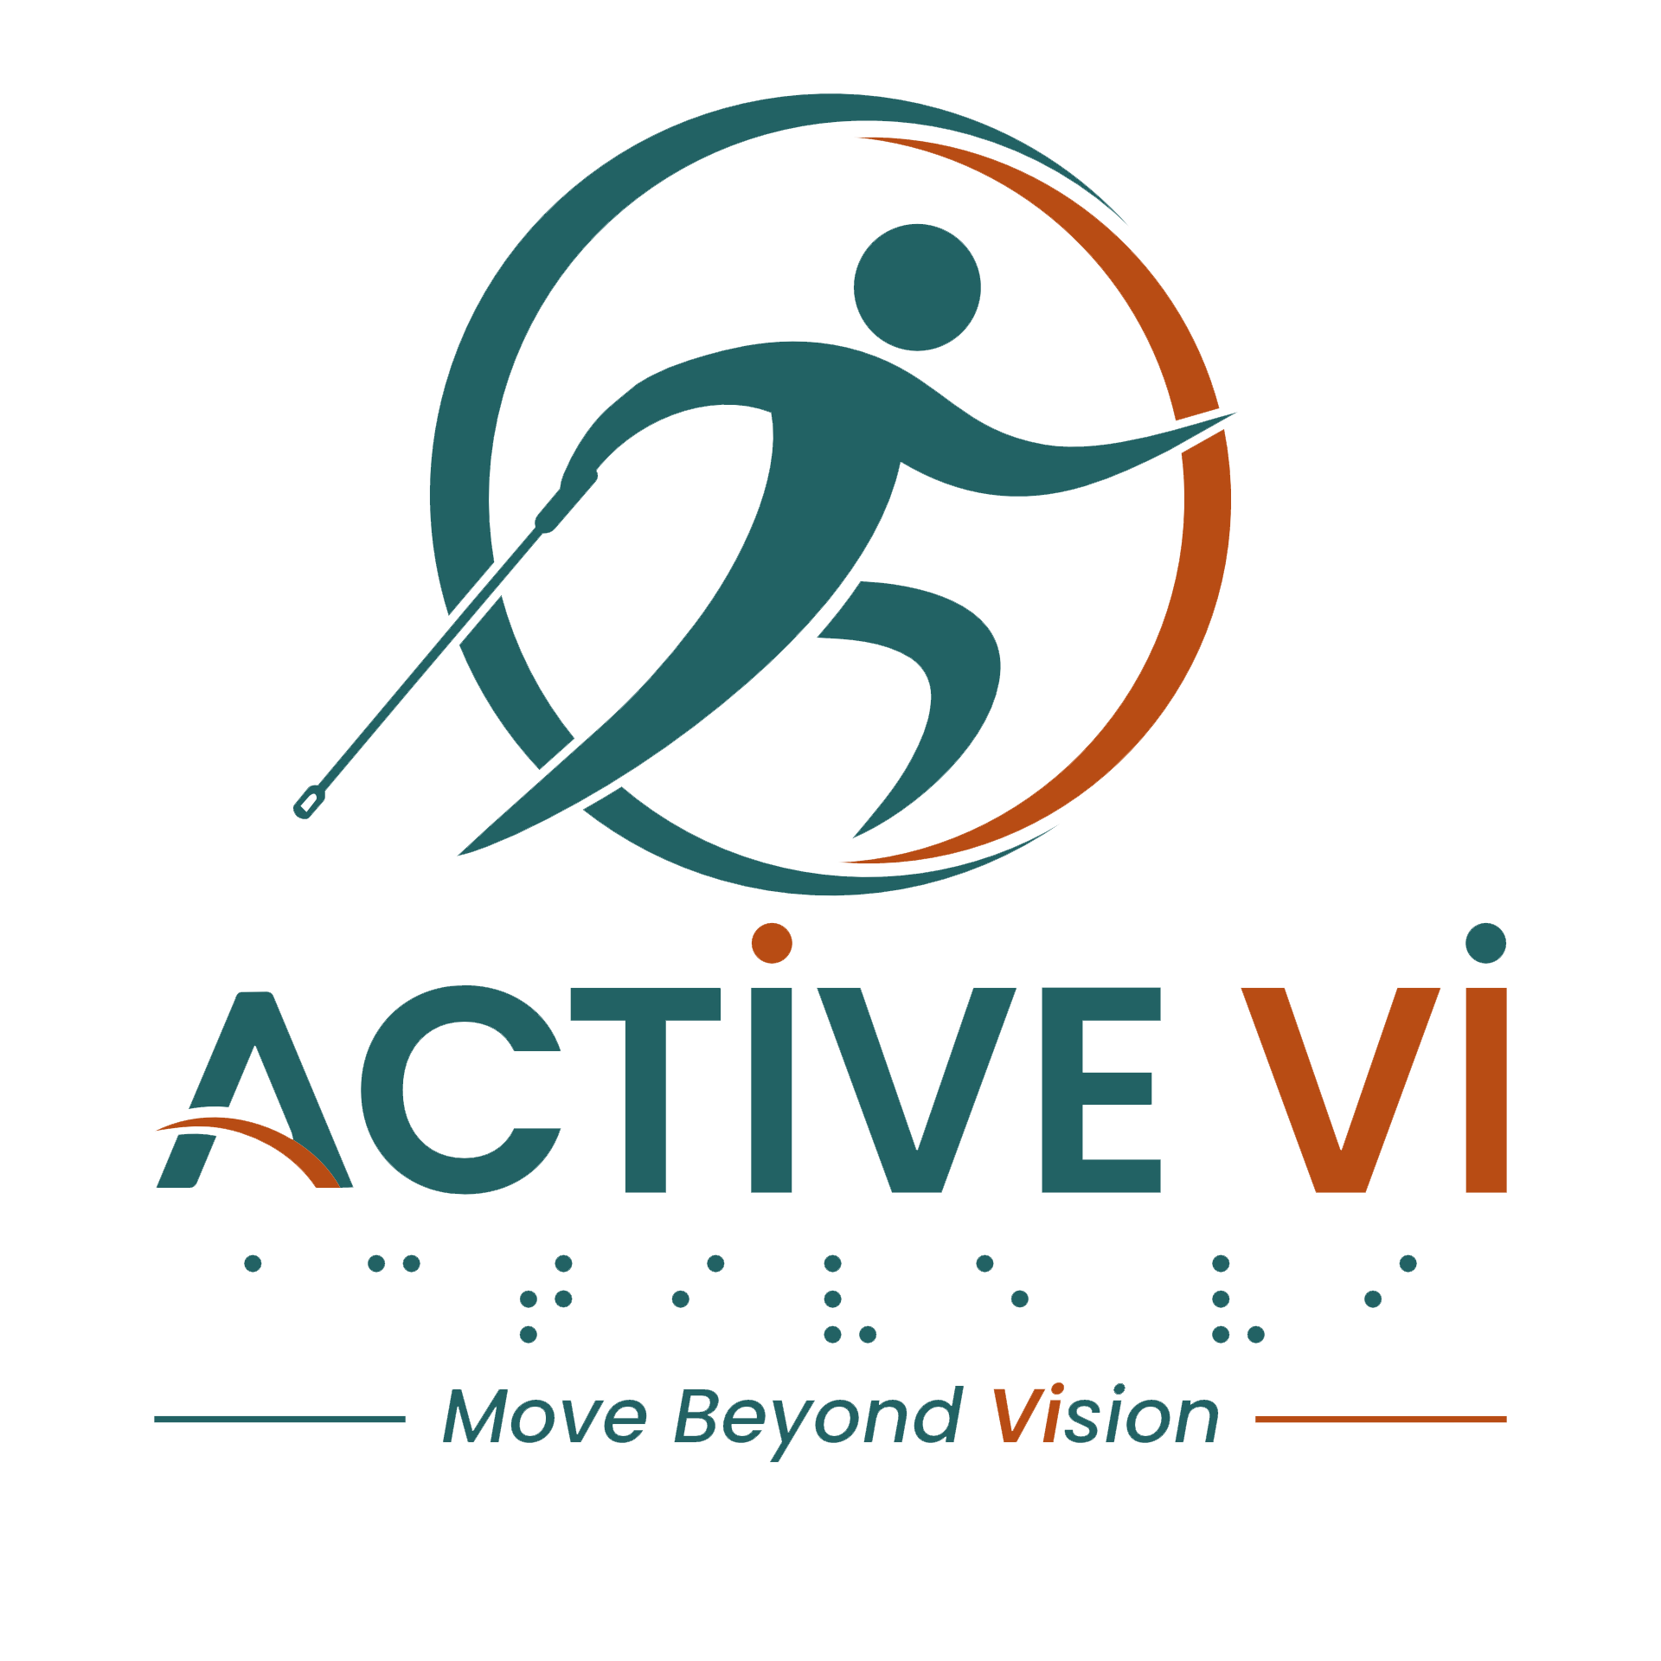

Transcript: Feel The Movement
[Background Music: Upbeat, energetic music plays throughout the video]
[Visual: The video opens with a poster for "Jump For Hope: Empowering Lives through Jumping Fitness." The event details list the dates as 17 to 18 April 2026 at the Sengkang Grand Mall Atrium, with the tagline "Every Jump Lifts a Life." The ACTIVE VI logo sits in the top right corner.]
[Visual: A female fitness professional guides a female participant on a mini-trampoline. On-screen text reads: "Move together".]
[Visual: A male participant stands on a mini-trampoline, guided by a female volunteer holding the handlebar. On-screen text reads: "Move together".] [Visual: Several visually impaired participants and volunteers are gathered around mini-trampolines in a spacious mall atrium. A volunteer guides a female participant’s hands to the trampoline handlebar. On-screen text reads: "Listen."]
[Visual: The female participant smiles at the camera. On-screen text reads: "Listen."]
[Visual: Close-up of a participant's feet stepping onto the trampoline mat. On-screen text reads: "This is what movement sounds like"]
[Visual: A volunteer is closely guiding a participant's arm to help her feel the correct movement. On-screen text reads: "Not by watching."]
[Visual: The volunteer continues to gently guide the participant's arm. On-screen text reads: "By feeling."]
[Visual: A volunteer points and gives verbal instructions to the participant. On-screen text reads: "A voice guides."]
[Visual: A wide shot of the group exercising together on mini-trampolines. A volunteer clapping and cheering for the participants. On-screen text reads: "Presence reassures."]
[Visual: The female participant smiles warmly. On-screen text reads: "Presence reassures."]
[Visual: Close-up of feet jumping rhythmically on the trampoline. On-screen text reads: "Movement becomes lighter."]
[Visual: The participant smiles brightly as she jumps. On-screen text reads: "Encouragement."]
[Visual: The participant continues jumping enthusiastically. On-screen text reads: "Confidence."]
[Visual: The group of participants and volunteers squat and jump to the beat. On-screen text reads: "Joy."]
[Visual: Close-up of numerous feet jumping on multiple trampolines. On-screen text reads: "You don’t need to see to be part of it."]
[Visual: Participants and volunteers hold the handlebars and bounce together happily. On-screen text reads: "Listen."]
[Visual: The group continues the jumping fitness routine as the camera pans to show more smiling participants enjoying the workout. On-screen text reads: "You just need to feel it."]
[Visual: The group jumps energetically to the beat. On-screen text reads: "Listen."]
[Visual: The participants continue bouncing. On-screen text reads: "Feel it."]
[Visual: A wide shot captures the entire event, with everyone jumping in unison across the spacious mall atrium. On-screen text reads: "Together."]
[Music: ACTIVE VI - Move Beyond Vision Jingle plays]
[Visual: The ACTIVE VI - Move Beyond Vision logo appears on screen along with the website www.activevi.sg.]
[Visual: The End Credits display on screen: Led by Singapore Institute of Technology (SIT) Health and Social Sciences. In Collaboration with Guide Dogs Singapore and Singapore Association of the Visually Handicapped (SAVH). Supported by Enabling Lives Initiative (ELI) Grant by SG Enable & Tote Board. Text displays the grant and copyright disclaimer: The video was produced by Enabling Lives Initiative Grant, with support from SG Enable. It is not to be reproduced in part or in whole, without the written permission of Tote Board and/or SG Enable.]
[Visual: Text displays: Special Thanks to: Participants and volunteers who contributed to the project, FireCity, Everyone supporting inclusive fitness and community connection.]
[Visual: The ACTIVE VI - Move Beyond Vision logo appears on screen along with the website www.activevi.sg.]
[End of transcript]

